<https://jamboard.google.com/d/1V_gfhldmBRK0mvlRk4-VV2LWfRRk-nwd3MrTrg0jtQE/viewer?f=0>

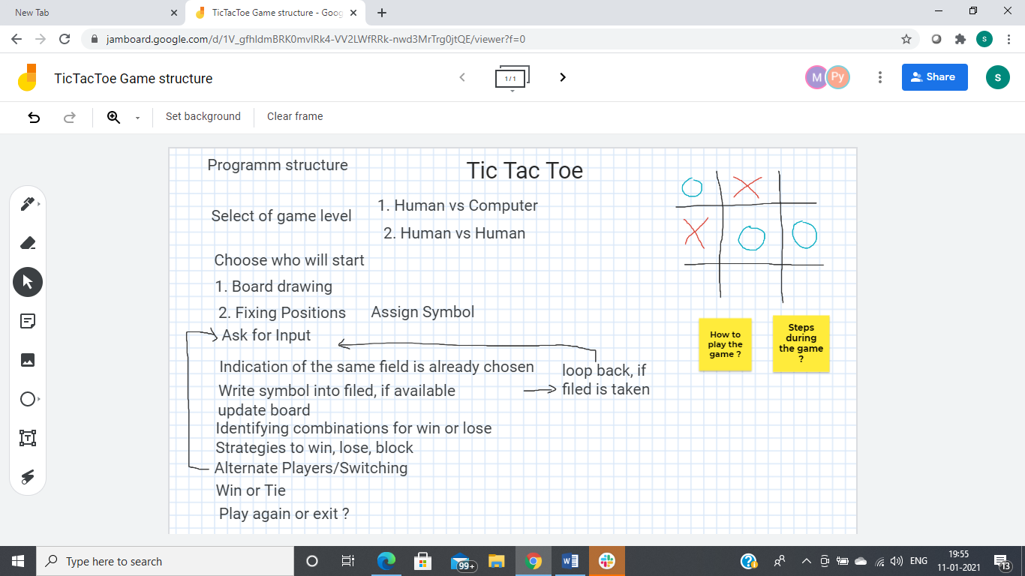

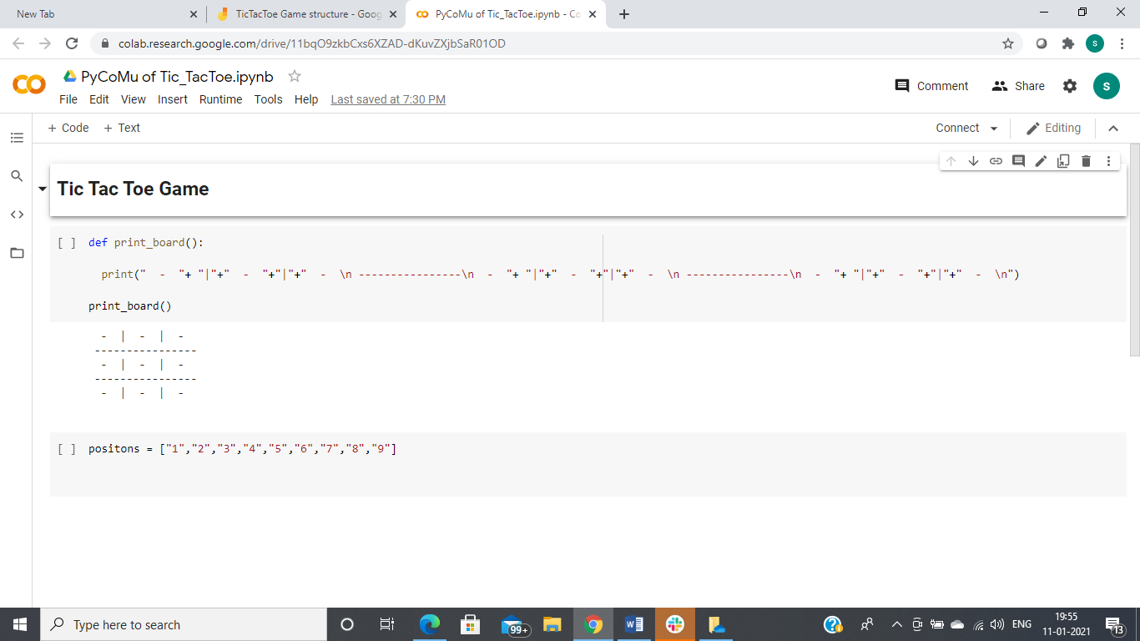

https://colab.research.google.com/drive/11bqO9zkbCxs6XZAD-dKuvZXjbSaR01OD